**Negative impacts of human development on Earth**

**Saurabh Sanap 1, Nikhil Tale 2 , Prof. Kirti randhe 3**

*1, *2Student, Department of Artificial Intelligence and Machine Learning, ISBM College of Engineering, Pune, Maharashtra, India

*3  HOD, Department of Artificial Intelligence and Machine Learning, ISBM College of Engineering, Pune, Maharashtra, India

**ABSTRACT**

We live on the same planet, why do we need a military and weapons? wars and nuclear attacks on the same planet? the state of the earth's environment etc. Human development has brought about numerous technological, economic, and social advancements that have transformed the way we live and work. However, this rapid progress has come at a great cost to the planet. The negative impacts of human development are evident in the depletion of natural resources, loss of biodiversity, pollution of air, water, and soil, and the effects of climate change and global warming. These negative consequences pose significant challenges for sustainable development and threaten the well-being of future generations. This paper explores the various negative effects of human development on Earth, including their causes and impacts, as well as solutions and alternatives to unsustainable development. Through a critical analysis of the challenges and limitations of sustainable development, this paper highlights the importance of addressing these issues and exploring alternative practices that prioritize the protection and preservation of the environment while balancing economic growth and social welfare. By doing so, we can ensure a sustainable future for our planet and all its inhabitants. research in space is vital for the future of humanity. By investing in space research, we can unlock new discoveries, technologies, and opportunities that have the potential to revolutionize our world and help us build a more sustainable future.

**Keywords:**  Nuclear, Global warming

1. **INTRODUCTION**

Pollution is the introduction of harmful substances or products into the environment. This can take many forms, including air pollution from vehicle exhaust and industrial emissions, water pollution from chemicals and waste products, and soil pollution from pesticides and other chemicals. Pollution has numerous adverse effects on human health, including respiratory problems, cancer, and birth defects. It also harms animals and plants, leading to biodiversity loss and ecosystem damage. Environmental degradation refers to the depletion or destruction of natural resources, such as forests, oceans, and wildlife habitats. Human activities such as deforestation, overfishing, and habitat destruction have contributed to this issue, leading to soil erosion, desertification, and climate change. The impact of environmental degradation can be felt in many ways, including food and water scarcity, increased natural disasters, and the displacement of communities. War has significant impacts on both the environment and human populations. During wars, natural resources such as forests and water sources are often exploited, leading to environmental degradation. The use of weapons such as bombs and chemicals can also cause long-lasting damage to ecosystems and contribute to pollution. The human toll of war is even more devastating, with countless lives lost or disrupted, homes destroyed, and infrastructure damaged.

Addressing these issues requires collective action from governments, businesses, and individuals. Policies must be put in place to limit pollution and protect natural resources. Sustainable practices must be promoted, including the use of renewable energy and conservation efforts. Diplomatic solutions must be sought to prevent conflict and war.

Ultimately, it is the responsibility of all of us to take care of the planet and each other. We must act now to address these pressing issues and secure a better future for ourselves and future generations. Nuclear attacks pose a grave threat to the safety and well-being of our planet and its inhabitants. As we all live on the same planet, the devastating effects of a nuclear attack would be felt by people all around the world. The use of nuclear weapons can lead to widespread destruction, loss of life, and long-term health effects, as well as environmental damage that can last for decades or even centuries. In addition, the political, social, and economic ramifications of a nuclear attack would be significant, with global instability and uncertainty likely to follow. Therefore, it is crucial that we work towards the prevention of nuclear attacks and the promotion of peace and diplomacy to ensure the safety and security of our planet and all those who call it home. The separation between countries can have several negative effects on our planet and its inhabitants. When nations become isolated and disconnected from one another, it can lead to a breakdown in communication and cooperation, hindering progress towards shared goals such as environmental protection, peace and security, and economic stability.

One of the most significant negative effects of separation between countries is the potential for conflict and war. When nations become divided, tensions can rise, leading to increased hostility and the possibility of military action. This can have devastating consequences for the environment, with damage to infrastructure and natural resources, as well as the loss of human life.

In addition, when countries become isolated, it can hinder efforts to address global issues such as climate change, pandemics, and poverty. These problems require global cooperation and collaboration to find effective solutions. Without a unified effort, progress towards a sustainable and equitable future can be impeded.

Finally, separation between countries can lead to social and economic disparities, with some countries enjoying greater prosperity and access to resources than others. This can contribute to feelings of inequality and injustice, leading to increased tension and conflict between nations.

In conclusion, the separation between countries can have significant negative effects on our planet and its inhabitants. It is crucial that we work towards greater cooperation and understanding between nations, promoting shared goals and values that benefit us all. By working together, we can address global challenges and create a more peaceful, equitable, and sustainable future for everyone.

1. **EVIDENCE**

The impact of weapons and wars on our planet is significant and can have far-reaching consequences. Some of the negative impacts include:

Environmental damage: Wars often result in environmental damage, including destruction of forests, pollution of water sources, and air pollution. The use of chemical weapons and nuclear weapons can also have long-term effects on the environment and wildlife.

Loss of biodiversity: Wars can result in the loss of biodiversity due to destruction of habitats, hunting, and pollution. This loss of biodiversity can have significant consequences for ecosystems and the long-term health of the planet.

Human displacement: Wars often result in the displacement of large numbers of people, who are forced to flee their homes and communities. This can lead to overcrowding, the spread of disease, and the loss of homes and livelihoods.

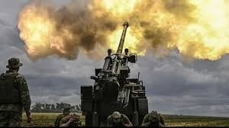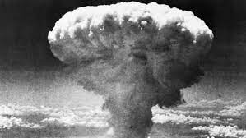

Fig. 1 world war

.

Health impacts: Wars can have significant health impacts, including physical injuries, mental health issues, and the spread of diseases due to overcrowding and lack of access to healthcare.

Resource depletion: Wars often result in the depletion of natural resources, including water, food, and fuel. This can lead to shortages and increased competition for resources, which can exacerbate existing conflicts and lead to further instability.

Overall, the impact of weapons and wars on our planet is significant and can have long-lasting consequences for both human and non-human life. It is important to work towards preventing and resolving conflicts in peaceful ways, and to prioritize the health and well-being of our planet and its inhabitants.

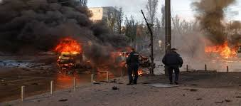

Fig. 2 Russia – Ukraine War

The rapid development and growth of human society over the past century have had several negative impacts on our planet. Some of the most significant effects of development on the planet include:

Climate Change: The burning of fossil fuels, deforestation, and other human activities have led to an increase in the concentration of greenhouse gases in the atmosphere. This has resulted in global warming, climate change, and extreme weather conditions.

Air Pollution: Industrial activities, transportation, and energy production have released pollutants into the air, leading to a range of health problems such as respiratory illnesses and heart disease.

Water Pollution: Industrial and agricultural runoff, oil spills, and wastewater discharge have polluted waterways and made it difficult for aquatic life to survive.

Deforestation: The clearing of forests for agriculture, urbanization, and other purposes has led to the loss of biodiversity, soil erosion, and increased greenhouse gas emissions.

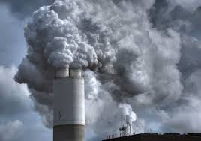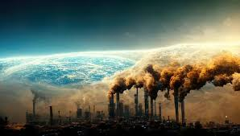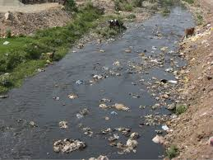



Fig. 3 Pollutions

Loss of Biodiversity: The destruction of natural habitats, overexploitation of resources, and climate change have led to a significant loss of biodiversity, threatening the survival of many species.

Soil Degradation: Overuse of fertilizers, pesticides, and intensive farming practices have degraded the quality of soil, leading to reduced agricultural yields and environmental degradation.

Resource Depletion: The demand for natural resources such as minerals, fossil fuels, and timber has led to the depletion of these resources and increased competition for access to them.

Overall, the negative impacts of development on our planet are significant and pose a threat to the health and well-being of both human and non-human life. It is important to adopt sustainable practices and promote environmental conservation to mitigate these impacts and ensure a planet for future generations.

Animals across the planet, from deep below the ocean's surface to those hiding in the trees of the Amazon, are dying off. The World Wildlife Fund studied more than 5,200 species for its Living Planet Report, and found that out of the nearly 32,000 populations analyzed, there was an average decline of 69% since 1970. Up to 2.5% of mammals, fish, reptiles, birds and amphibians have already gone extinct, the report says.

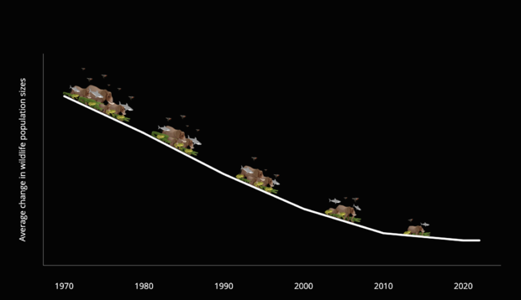

Fig. 4 Graph of Wildlife population

Scientists named a new species of whale last year. Now, they're "on the edge of extinction."

And the average population numbers have only gotten worse. Four years ago, the Living Planet report found a 60% average decline. Then in 2020, the average hit 68% – a situation that was called an "SOS for nature."

Now, two years later, authors of the report say the continued decline is a "code red for the planet (and humanity)" as some scientists warn that Earth is heading toward another mass extinction, mostly due to climate change.

"The message is clear and the lights are flashing red. Our most comprehensive report ever on the state of global vertebrate wildlife populations presents terrifying figures: a shocking two-thirds decline in the global Living Planet Index less than 50 years," WWF International's Director General Marco Lambertini says in the report.

1. **CONCLUSION**

Based on the research and analysis presented in this report, it is clear that human development has had a negative impact on planet Earth. Our activities, including the burning of fossil fuels, deforestation, and pollution, have resulted in significant damage to the environment and its ecosystems.

The effects of these activities are far-reaching, including climate change, loss of biodiversity, and depletion of natural resources. These impacts have the potential to cause irreparable harm to the planet, and ultimately to human life as well.

It is crucial that we take action to mitigate these negative effects and work towards sustainable development that balances economic growth with environmental protection. This will require significant changes in policy, behavior, and technology, as well as a global commitment to prioritize the health and well-being of the planet and all its inhabitants.

In conclusion, the negative impact of human development on planet Earth is a serious issue that requires urgent attention and action. We must work together to find solutions and implement changes to ensure a sustainable future for generations to come.

Also need to thought on question’s –

1)How to stop increasing pollutions?

2)When we share the same planet, we really need a military, Weapons, Nuclear weapons?

3)To be used on the same planet where we are living, nuclear weapons are truly needed?

4)When will everyone on the planet begin to feel proud of their planet and the idea that the entire world is their home?

1. **REFERENCES**

[1] Wikipedia

[2] News Letters (The Climate Crisis)

[3] Book (Understanding Environmental Pollution: A Primer) Originally published: 13 October 1997

Author: Marquita K. Hill

[4] Markham, A. 1994. A Brief History of Pollution. New York: St. Martin's Press. 162 pp.